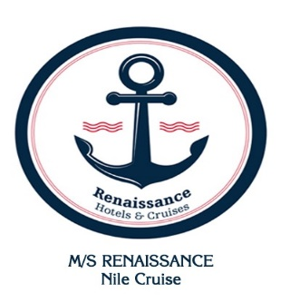
Fact Sheet
MS / Renaissance Nile Cruise.

Floating Hotel features:
- Completely Renovated & Upgraded November 2024
- 75 Luxurious Cabins and 1 suite (68 Main & Upper decks +8 Lower deck).
- Reading and Relaxing Lounge + TV.
- Boutique, gift shop.
- Large Restaurant (150 seats) & Beverage’s station for Breakfast.
- Large Reception
- Lounge/ bar/ disco (150 seats)
- Sundeck equipped with swimming pool, shallow water pool for children., bar and fitness machines (Treadmill, Electric Fitness Bike and Tennis Table) free of charge
- Laundry service against charge
- Spa :
*Fitness machines (Treadmill & Electric Fitness Bike) free of charge
*Massage room, Jacuzzi and Sauna against charge
- WIFI against charge (Only 500 MB free of charge upon arrival available at Lounge bar & Reception)

Guest Cabins:
- 10 King size, 65 twin bedded.
- Private butler service and 24 hours room service.
- Luxurious bathrooms.
- In- Room personal safe box
- All Cabins with Nile View and panoramic opening windows.
- Each Cabin has hair dryer, TV, Air-conditioning, mini bar, smoke detector, internal
telephone and music channels on TV.
- TV with satellite channels during sailing and docking
- In- room amenities

- Technical Sheet
- Applying TÜV NORD. Egypt- worldwide risk management systems for food hygiene &
sanitation on board+ Water Purification station on board +Ultraviolet.
- Electric current 220-volt, ac/50 cycles
- Sprinklers, anti-fire treatment and full fire safety.
- Length 72.00 meters
- Width: 13.50 meters
- Height 11.70 meters
- Draft 1.60 meters
- 3 Engines + 3 Propellers.
- 3 Generators for electricity.

